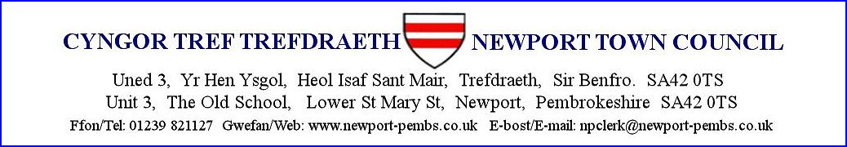

**AGENDA AM CYFARFOD CYLLIDEB A CHYLLID HYBRID I’W GYNNAL ar 17eg EBRILL 2025 am 7yh**

**AGENDA FOR THE HYBRID BUDGET AND FINANCE MEETING TO BE HELD on 17th APRIL 2025 at 7pm**

You are hereby summoned to attend an online meeting of Newport Town Council for the purpose of transacting the following business.

If a member of the public/press wishes to attend the meeting online, please email the Clerk on [npclerk@newport-pembs.co.uk](mailto:npclerk@newport-pembs.co.uk) by **14th April.**

1. **Ymddiheuriadau am absenoldeb / Apologies for absence**
2. **Datganiad o ddiddordeb / Declarations of Interest**
3. **Cofnodion o’r cyfarfod a gynhaliwyd ar 18fed Rhagfyr 2024 / Minutes of the meeting held on 18th December 2024**
4. **Cyllid / Finance**

**Arian a dderbyniwyd / Monies received:**

Street market deposits £…..

**Cyfrifon i’w talu / Accounts to be paid**

|  |  |
| --- | --- |
| J. Austin, Market Manager hours | £180.00 |

1. **Adolygiad ariannol / Financial review**
   1. Receipts and payments
   2. Income/expenditure actuals to budget
   3. Bank reconciliation
   4. Variances
   5. Capital and reserves accounts
   6. Notes and assets
   7. High interest savings account
2. **Dadansoddiad risg / Risk analysis**
3. **Grwp gweithio Pecyn Cymorth Cyllid a Llywodraethu / Finance & Governance Toolkit Working group**
4. **Adolygu'r Rheoliadau Ariannol / Review the Financial Regulations**
5. **Trafod cytundeb cyflogaeth newydd Clerc y Dref / Discuss new contract of employment for Town Clerk**
6. **Apeliadau ariannol / Financial appeals**
   1. Donation / funding request for £1,000 from Newport Memorial Hall for Caffi Cwtch project and new crockery for the hall
   2. Llangollen International Eisteddfod
7. **Ffurflen flynyddol swyddfa Archwilio Cymru / Welsh Audit office annual return**
8. **Adeilad Hostel Ieuenctid / Youth Hostel building**
9. **Cyfatebiad / Correspondence**

**Dyddiad y cyfarfod nesaf / Date of next meeting**