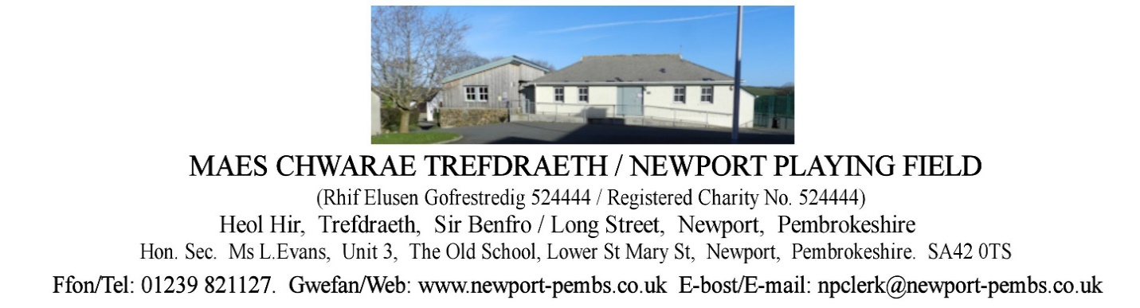

**AGENDA O CHYFARFOD HYBRID O YMDDIRIEDOLWYR I’W CHYNNAL AM 7yh ar**

**10fed MAWRTH 2025**

**AGENDA OF TRUSTEES HYBRID MEETING TO BE HELD ON 10th MARCH 2025 at 7pm**

You are hereby summoned to attend an online meeting of Newport Playing field Trustees for the purpose of transacting the following business.

If a member of the public/press wishes to attend the meeting online, please email the Clerk on [npclerk@newport-pembs.co.uk](mailto:npclerk@newport-pembs.co.uk) by 7th March 2025.

1. **Ymddiheuriadau am absenoldeb / Apologies for absence**
2. **Datganiad o ddiddordeb / Declarations of Interest**
3. **Cofnodion draft o’r cyfarfod a gynhaliwyd ar 14eg Ionawr 2025 / Draft Minutes of the meeting held on 14th January 2025**
4. **Materion yn Codi / Matters arising**
5. **Adroddiad y Cadeirydd / Chair’s Report**
6. **Adroddiad y gofalwr / Caretaker’s report**
7. **Adroddiad Clwb Llewod Trefdraeth / Newport Lion’s Football Club report**
8. **Adroddiad Clwb Tigwyr Trefdraeth / Newport Tiger’s Club report**
9. **Adroddiad Crwban Bach / Crwban Bach report**
10. **Adroddiadau arolwg / Inspection reports**
    1. Skate Park inspection
    2. Playing field inspection
    3. ROSPA inspection
    4. Smart meter in changing rooms
11. **Parc Sglefrio /** **Skate Park**
    1. Skate Park lease
12. **Yswiriant / Insurance**
13. **Tir drws nesaf i 13 Maes Morfa / Land next to 13 Maes Morfa**
14. **Prydlesi a chytundebau / Leases and agreements** 
    1. Land leased to Mr and Mrs. Sneade
    2. Terms of use with playing field users
15. **Gofalwr yr ystafelloedd newid / Changing rooms Caretaker**
16. **Adroddiad grŵp Tasg a Gorffen maes chwarae / Playing field Task & Finish group report**
17. **Cyllid / Finance**

**Arian a dderbyniwyd / Monies received:**

**Cyfrifon i’w talu / Accounts to be paid:**

|  |  |
| --- | --- |
| Changing rooms caretaker hours |  |
| Dŵr Cymru DD (p.m) | £19.00 (up from £13) |
| British Gas – Gas DD (p.m) | £56 (up from £13.00) |
| British Gas – electric (DD) | £48 (Down from £79, up from £65 and £53.00) |
| Dyfed Alarms, renewal of fire extinguisher annual service agreement, Mar 2025-Feb 2026 | £12.00 |

* 1. Decrease in Electric bill
  2. Advertising Dros Blant room hire
  3. Review fees and insurance documents for playing field users
  4. Cash flow spreadsheet
  5. Container planning application for the Football Club
  6. Dan’s skate park services and repairs

1. **Gohebiaeth / Correspondence** 
   1. Email to JCP solicitors regarding possible sale of land
   2. Email received from C. Stockwell, PCC re Childcare setting query/advert on Facebook
   3. Email from Higos stating “As your policy has lapsed with Higos, we assume any legal issue ongoing, you will take up with your new insurer and we hope any dispute is resolved.”
2. **Taflen RAG / RAG sheet**