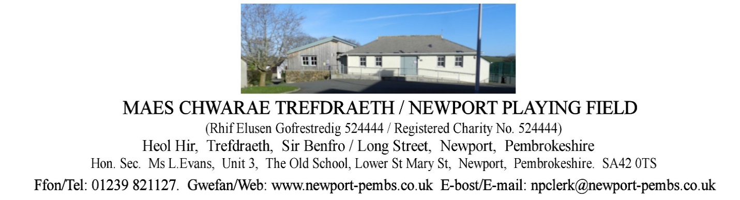

**AGENDA O CHYFARFOD HYBRID O YMDDIRIEDOLWYR I’W CHYNNAL AM 7yh ar 14eg**

**IONAWR 2025**

**AGENDA OF TRUSTEES HYBRID MEETING TO BE HELD ON 14th JANUARY 2025 at 7pm**

You are hereby summoned to attend an online meeting of Newport Playing field Trustees for the purpose of transacting the following business.

If a member of the public/press wishes to attend the meeting online, please email the Clerk on [npclerk@newport-pembs.co.uk](mailto:npclerk@newport-pembs.co.uk) by 12th January 2025.

1. **Ymddiheuriadau am absenoldeb / Apologies for absence**
2. **Datganiad o ddiddordeb / Declarations of Interest**
3. **Cofnodion draft o’r cyfarfod a gynhaliwyd ar 20fed Tachwedd 2024 / Draft Minutes of the meeting held on 20th November 2024**
4. **Materion yn Codi / Matters arising**
5. **Cofnodion draft o’r cyfarfod a gynhaliwyd ar 26ain Tachwedd 2024 / Draft Minutes of the meeting held on 26th November 2024**
6. **Materion yn codi / Matters arising**
7. **Adroddiad y Cadeirydd / Chair’s Report**
8. **Adroddiad y gofalwr / Caretaker’s report**
9. **Adroddiad Clwb Llewod Trefdraeth / Newport Lion’s Football Club report**
10. **Adroddiad Clwb Tigwyr Trefdraeth / Newport Tiger’s Club report**
11. **Adroddiad Crwban Bach / Crwban Bach report**
12. **Adroddiadau arolwg / Inspection reports**
    1. MUGA inspection
13. **Parc Sglefrio /** **Skate Park**
    1. Skate Park lease
14. **Yswiriant Higos insurance**
    1. Loss recovery insurance quote, £153.61
15. **Tir drws nesaf i 13 Maes Morfa / Land next to 13 Maes Morfa**
16. **Prydlesi a chytundebau / Leases and agreements** 
    1. Land leased to Mr and Mrs. Sneade
    2. Terms of use with playing field users
17. **Adroddiad grŵp Tasg a Gorffen maes chwarae / Playing field Task & Finish group report**
18. **Cyllid / Finance**

**Arian a dderbyniwyd / Monies received:**

**Cyfrifon i’w talu / Accounts to be paid:**

|  |  |
| --- | --- |
| Changing rooms caretaker hours |  |
| Dŵr Cymru DD (p.m) | £19.00 (up from £13) |
| British Gas – Gas DD (p.m) | £56 (up from £13.00) |
| British Gas – electric (DD) | £79 (up from £65 and £53.00) |
| Dyfed Alarms, renewal of fire alarm service agreement 2025 | £84.00 |
| Zurich insurance (paid) | £960.28 |

* 1. Increase in energy bills
  2. Advertising Dros Blant room hire
  3. Review fees and insurance documents for playing field users
  4. Cash flow spreadsheet
  5. Container planning application for the Football Club
  6. Dan’s skate park services and repairs

1. **Gohebiaeth / Correspondence** 
   1. Email from M A. Sneade re surveyor’s report and land agents’ comments re land at 13 Maes Morfa (26.11.24)
   2. Email from Cllr. Lewis with image of the 2 boundary lines drawn at land next to 13 Maes Morfa (15.12.24)
   3. Email from G. Davies re boundary line between plot adjacent to 13 Maes Morfa (28.12.24)
2. **Taflen RAG / RAG sheet**