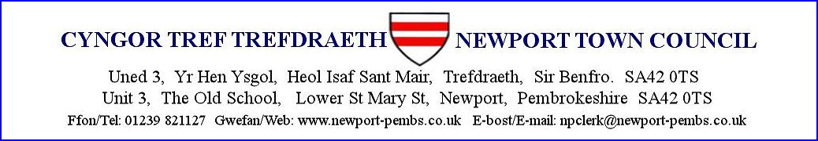

**AGENDA AM CYFARFOD ANGHYFFREDIN HYBRID I’W GYNNAL ar 18fed CHWEFROR 2025 am 7yh**

**AGENDA FOR THE EXTRAORDINARY HYBRID MEETING TO BE HELD on 18th FEBRUARY 2025 at 7pm**

You are hereby summoned to attend a **HYBRID** meeting of Newport Town Council for the purpose of transacting the following business.

If a member of the public/press wishes to attend the meeting online, please email the Clerk on [npclerk@newport-pembs.co.uk](mailto:npclerk@newport-pembs.co.uk) by **15th February 2025.**

1. **Ymddiheuriadau am absenoldeb / Apologies for absence**
2. **Datganiad o ddiddordeb / Declarations of Interest**
3. **Datblygiad Maes Ingli Development**