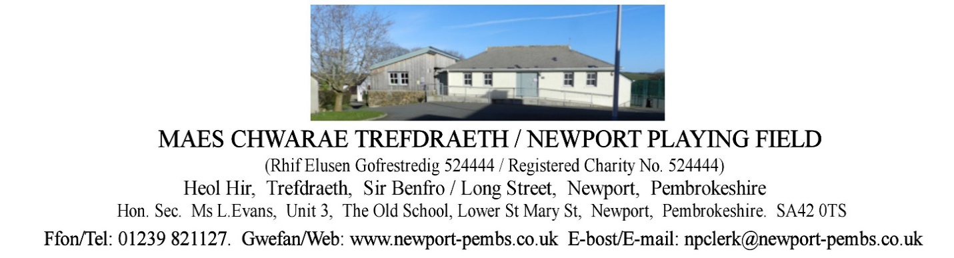

**AGENDA O CHYFARFOD HYBRID O YMDDIRIEDOLWYR I’W CHYNNAL AM 7yh ar 20fed**

**TACHWEDD 2024**

**AGENDA OF TRUSTEES HYBRID MEETING TO BE HELD ON 20th NOVEMBER 2024 at 7pm**

You are hereby summoned to attend an online meeting of Newport Playing field Trustees for the purpose of transacting the following business.

If a member of the public/press wishes to attend the meeting online, please email the Clerk on [npclerk@newport-pembs.co.uk](mailto:npclerk@newport-pembs.co.uk) by 17th November.

1. **Ymddiheuriadau am absenoldeb / Apologies for absence**
2. **Datganiad o ddiddordeb / Declarations of Interest**
3. **Cofnodion draft o’r cyfarfod a gynhaliwyd ar 3ydd Medi 2024 / Draft Minutes of the meeting held on 3rd September 2024**
4. **Materion yn Codi / Matters arising**
5. **Adroddiad y Cadeirydd / Chair’s Report**
6. **Adroddiad y gofalwr / Caretaker’s report**
7. **Adroddiad Clwb Llewod Trefdraeth / Newport Lion’s Football Club report**
8. **Adroddiad Clwb Tigwyr Trefdraeth / Newport Tiger’s Club report**
9. **Adroddiad Crwban Bach / Crwban Bach report**
10. **Adroddiadau arolwg / Inspection reports**
    1. MUGA inspection
11. **Parc Sglefrio /** **Skate Park**
    1. Skate Park lease
12. **Yswiriant Higos insurance**
    1. Loss recovery insurance quote, £153.61
13. **Tir drws nesaf i 13 Maes Morfa / Land next to 13 Maes Morfa**
14. **Prydlesi a chytundebau / Leases and agreements** 
    1. Land leased to Mr and Mrs. Sneade
    2. Terms of use with playing field users
15. **Adroddiad grŵp Tasg a Gorffen maes chwarae / Playing field Task & Finish group report**
16. **Cyllid / Finance**

**Arian a dderbyniwyd / Monies received:**

Crwban Bach, rental £180.00

Newport Lion cubs Football Club £112.00

**Cyfrifon i’w talu / Accounts to be paid:**

|  |  |
| --- | --- |
| Changing rooms caretaker hours |  |
| Dŵr Cymru DD (p.m) | £13.00 (down from £20) |
| British Gas – Gas DD (p.m) | £56 (up from £13.00) |
| British Gas – electric (DD) | £79 (up from £65 and £53.00) |

* 1. Increase in energy bills
  2. Advertising Dros Blant room hire
  3. Review fees and insurance documents for playing field users
  4. Cash flow spreadsheet
  5. Container planning application for the Football Club
  6. Dan’s skate park services and repairs
  7. MUGA hourly increase wage
  8. Annual return

1. **Gohebiaeth / Correspondence** 
   1. Email to all users regarding key access to facilities
   2. Email to all users inviting to meet to discuss terms of use
2. **Taflen RAG / RAG sheet**