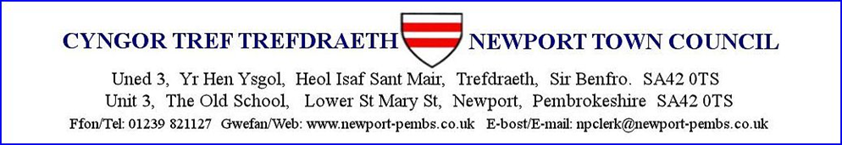

**Draft Notes of Planning Meeting 23rd Sept 2024**

**1. Present :** Morgan (chair);Ros (notes); Paul; Sandra; Darren; Jackie

**Apologies**: John, Elaine; Jon

**2. Declarations of interest**: None

**3. Draft minutes of meeting held on 19th Aug 2024**: Nothing

**4. Matters Arising**: None

**5. Planning Applications**

**5.1 NP/ 24/0363/FUL Ecton House**

Conservation officer requires further information and has requested a site meeting.

1. Newport Town Council suggest a site visit before any decisions are made.

2. Green infrastructure not submitted.

3. Require confirmation of curtilage.

**5.2 NP/24/0437/FUL Llys y Coed**

Despite concerns about light spillage the council approved the application by a majority. Paul proposed, Darren seconded, Sandra abstained.

**5.3 Greystones**

The council approved the application, however, the council in future would expect drawings with scaled dimension and levels relating to datum. Paul proposed, Darren seconded, all agreed.

**5.4 Penffynnon**

The council approved the application. Paul proposed, Jackie seconded, all agreed.

**6. Treeworks**

**7. Treeworks in Conservation areas**

7.1 NP/ 24/0432/TCA Rosedale: Paul proposed approval, Darren seconded, all agreed.

7.2 NP/24/0434/TCA Ty Cerrig: Paul proposed approval, Darren seconded, all agreed.

7.3 NP/24/0479/TCA Beehive: Paul proposed approval, Darren seconded, all agreed.

**18. Correspondence**

**18.1 Feidr Eglwys development**: No reply

**18.2 Request from Dyfed Family History society**

NTC support the Cardigan Branch of Dyfed Family History Society and agree to the conducting of a survey of the memorial inscriptions at Brynhyfryd as long as the council has the reassurance that the cemetery will be left as it is found.

**18.3 Re: Community Wellbeing Action Plans**

Paul proposed the email from Tom Moses is considered as an appendix at the next full council meeting.