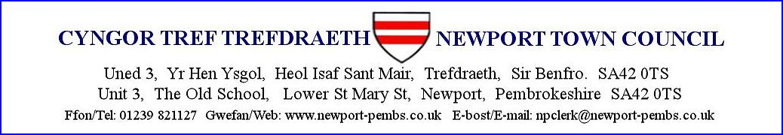

**AGENDA AM CYFARFOD HYBRID I’W GYNNAL ar 30eg MEDI 2024 am 7yh**

**AGENDA FOR THE HYBRID MEETING TO BE HELD on 30th SEPTEMBER 2024 at 7pm**

You are hereby summoned to attend a **HYBRID** meeting of Newport Town Council for the purpose of transacting the following business.

If a member of the public/press wishes to attend the meeting online, please email the Clerk on [npclerk@newport-pembs.co.uk](mailto:npclerk@newport-pembs.co.uk) by **27th September.**

1. **Ymddiheuriadau am absenoldeb / Apologies for absence**
2. **Datganiad o ddiddordeb / Declarations of Interest**
3. **Cofnodion drafft o’r cyfarfod gynhaliwyd ar 2ail Medi 2024 /** **Draft minutes of the meeting held on 2nd September 2024**
4. **Materion yn codi / Matters arising**
5. **Cofnodion drafft o’r cyfarfod anghyffredin a gynhaliwyd ar 9fed Medi 2024 / Draft minutes of the extraordinary meeting held on 9th September 2024**
6. **Materion yn codi / Matters arising**
7. **Adroddiad y Cadeirydd / Chair’s report**
8. **Adroddiadau/penderfyniadau pwyllgorau cynghori / Advisory committee reports/decisions**
   1. Community Needs, Assets, Projects and Grants
9. Draft letter to PCNPA concerning land at Pen y Bont
   1. Traffic
   2. Street market
   3. Housing survey
   4. Priorities, Environment and Climate task and finish
10. **Datblygiad llety gwarchod Maes Ingli / Maes Ingli sheltered accommodation development**
11. **Dogfennau llywodraethu / Governance documents**
    1. GD14 – Financial regulations
12. **Tir Parrog a toiledau cyhoeddus / Parrog land and public toilets**
    1. Valuation
    2. Public meeting notes
13. **Ystyried gwahardd y cyhoedd o'r cyfarfod ar gyfer yr eitem ganlynol o fusnes: / To Consider excluding the public from the meeting for the following item of business:** 
    1. The Old School building
14. **Dŵr Cymru**
15. **Archwiliad Blynyddol Cymru / Annual Audit Wales**
16. **Cyllid / Finance**

**Arian a dderbyniwyd / Monies received**

Street market deposits £………

**Cyfrifon i’w talu / Accounts to be paid:**

|  |  |
| --- | --- |
| Town Clerk Pay (SO) p.m. | £1,042.18 |
| Nest, Clerk and council pension payments | £38.52 |
| Unit 3 rental (DD) p.m. | £150 (vat £25) |
| Council Tax (DD) p.m. | £174.00 |
| BT Telephone/internet (DD) p.m. | £0.00 |
| Good energy (electric) (DD) p.m. | £77.04 (up from £27.00) |
| Google workspace | £6.00 |
| Spindogs, Basic monthly website care package (DD) | £96.00 (incl. vat £16.00) |
| Newport Post Office, printing paper and sympathy card | £9.85 |
| Trade waste agreement, PCC | £58.60 |
| OVW, Biodiversity part 1, councillor training | £20 (bursary of £20 applied) |
| Rees Richards & Partners, valuation of Parrog land | £1,170.00 (vat £195) |

* 1. Town Clerk’s job description and contract of employment
  2. Telephone contract changeover from PlusNet to BT and outstanding bills
  3. Unit 3 insulation
  4. Trade waste agreement
  5. Christmas lights
  6. Rental charge for Unit 3

1. **Maes chwarae plant / Children’s play area**
2. **Ymgysylltiad ieuenctid / Youth engagement**
3. **Blac ar adeilad i goffau Canolfan Eco Gorllewin Cymru / Plaque on building to commemorate West Wales Eco Centre**
4. **Llwybr Parc y Plant o’r maes parcio / Parc y plant footpath from the car park**
5. **Tudalen RAG / RAG sheet**
6. **Materion i adrodd arnynt / Matters to report**
   1. Proposed underlease to Newport Information Centre
   2. Website update
   3. New bank signatory
   4. Victoria gardens ownership
   5. A487 Royal Oak culvert works
7. **Cyfatebiad / Correspondence**

**Dyddiad y cyfarfod nesaf / Date of next meeting**